Project Design Phase-I
Solution Architecture

Date | 19 September 2022
Team Id | LTVIP2026TMIDS36439
Project Name | Toycraft Tales Tableau's vision into Toy manufactures Data
Maximum Marks | 4 Marks

Solution Architecture:

Solution architecture in ToyCraft Tales is a structured process that connects toy manufacturing business challenges with powerful data-driven solutions using Tableau.It helps transform raw toy industry data into meaningful insights for smarter decision-making.

- External Entities: Any third-party data sources (like the Toy Trend Dataset).

- Integration Points: How the Application "talks" to the AI (usually via APIs).

- Security Gates: Firewalls or Authentication layers that protect the manufacturer's internal data.

- Data Sinks: Where the final "Tableau" or visualization is stored after the D3 Visualizer finishes its work.

Key Components to Include

- External Entities: Any third-party data sources (like the Toy Trend Dataset).

- Integration Points: How the Application "talks" to the AI (usually via APIs).

- Security Gates: Firewalls or Authentication layers that protect the manufacturer's internal data.

- Data Sinks: Where the final "Tableau" or visualization is stored after the D3 Visualizer finishes its work.

Example - Solution Architecture Diagram:

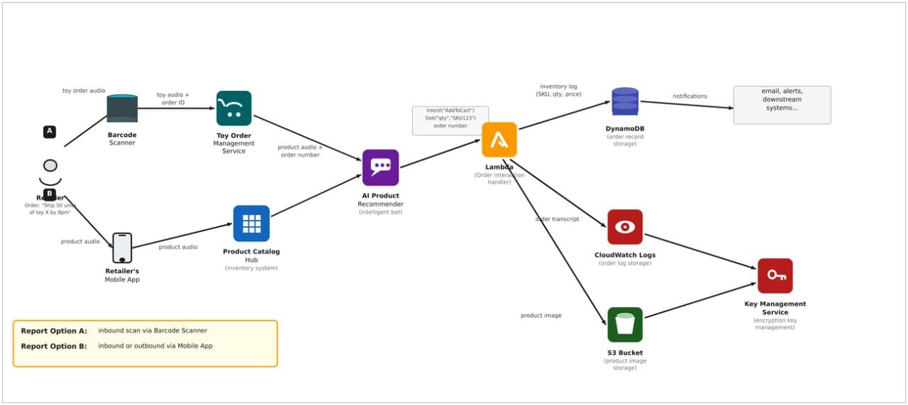

Figure 1: Architecture and data flow of the voice patient diary sample application

Reference:
https://aws.amazon.com/blogs/industries/voice-applications-in-clinical-research-
powered-by-ai-on-aws-part-1-architecture-and-design-considerations/

